- IMPLEMENTATION STRATEGY
- Institutional and Implementation Arrangements

- The distinctive characteristic of this project is its integrated approach to the training, mentoring and support of beneficiaries. To this end, the project will bring together specialized agencies from public, private and civil sectors under the leadership of the MIGEPROF to provide the wide range of services necessary to implement the project.

- Local government also has a critical role to play in implementation and coordination. District and sector officials will play an active role in the assessment of beneficiaries, identification of training facilities, formation of cooperatives, and support in accessing local markets.

- Chart 1 depicts project institutional arrangements.

Chart 1: Institutional Relationships
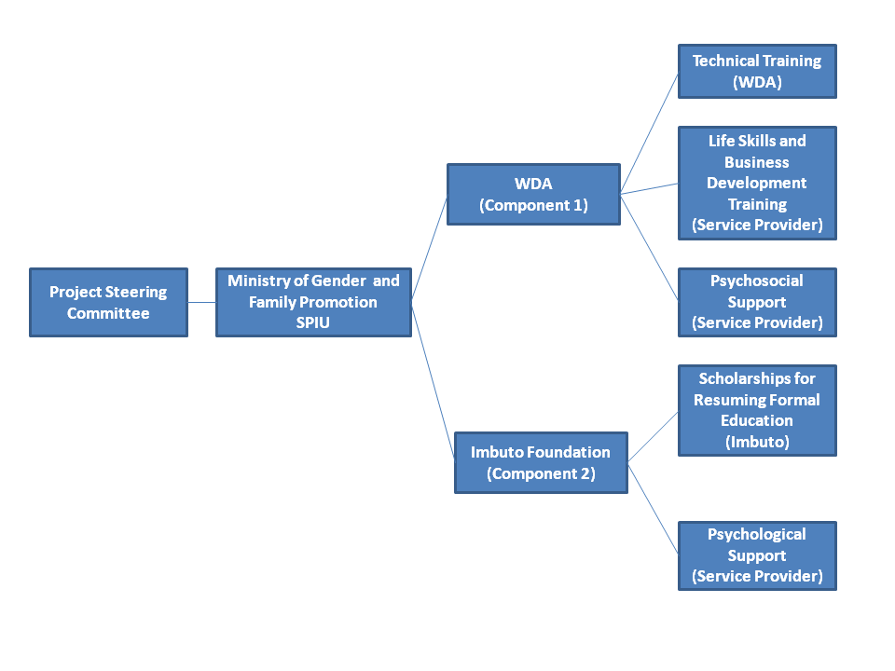

- A Project Steering Committee comprised of relevant Ministries (MIGEPROF, MINECOFIN and MINIYOUTH), agencies (WDA, PSF and RCA) and civil society (Imbuto Foundation) will provide oversight. The MIGEPROF will provide overall leadership, management and coordination through an integrated Single Project Implementation Unit (SPIU) to be integrated into the Ministry.

- Key institutions to be involved in project management include:

- Imbuto Foundation: Imbuto Foundation was created in 2007, to support the development of a healthy, educated and prosperous society. One of its main activities is the promotion of education of all children, particularly girls, an area in which it has already established an impressive track record. The Imbuto Foundation will implement Component 2 with support from MIGEPROF.

- Workforce Development Authority (WDA): WDA is mandated to promote, facilitate and guide the development and upgrading of skills and competencies of the national workforce, ultimately enhancing competitiveness and employability. It will be responsible for the provisions of day to day field management and coordination of the first component of the project. Its tasks will include: (a) managing the design of technical training curriculum; (b) recruiting through a competitive process, and assigning as required trainers/ mentors, trainers of trainers, and project field staff; (c) provide necessary training to the above, (d) procurement of technical training equipment and materials; (e) designing and delivering entrepreneurship and life skills curriculum and psychos-social support in partnership with specialized service providers and coordination of contracts for the provision of such services; (f) monitoring of training quality; (g) coordination of mentoring arrangements, provision of continuing business development support to beneficiaries; and support cooperative formation, business plans development, and links with micro-finance institutions; (h) monitoring technical trainers and facilitators at each location; (i) disbursing stipend funds to beneficiaries and managing contributions to savings according to project policy and rules; (j) testing certification of beneficiaries upon completion of vocational training; (k) working with district and sector level government officials to identify and launch vocational training in each project location; (l) coordination of beneficiary selection locally, including media campaign; and (m) providing on-going monitoring data to feed into MIGEPROF reporting.

- Psychosocial service provider (contractor): A specialist Rwandan organization will be selected to provide support to beneficiaries in Component 2, as well as the following services for Component 1: (a) integrate psychosocial aspects into the life skills curriculum and mentoring programs; (b) train project field staff, trainers and scholarship mentors to identify possible signs of depression, stress, and trauma and to refer them to appropriate professionals; and (c) provide counseling services to beneficiaries referred by the project.

- The fiduciary arrangements for the Rwanda - Economic Empowerment of Adolescent Girls and Young Women Project will be broadly similar to the support provided by the Office of the Prime Minister: “the PRIMATURE” to the Ministry of Gender and Family Promotion, MIGEPROF, which is responsible for implementing the project. The project will receive disbursements from IDA on the basis of incurred eligible expenditures (transaction-based disbursements). Upon Grant effectiveness, an initial advance will be disbursed from the proceeds of the IDA grant and will be deposited into a Project-operated Designated Account (DA) to expedite Project implementation.

- Monitoring and Evaluation of Outcomes / Results

- The results framework for the project is provided in Annex 7. Monitoring will be the responsibility of the MIGEPROF, specifically of the Project Manager, supported by a M&E Assistant (part time). The Ministry will develop a monitoring plan for the various activities and components, and monitoring data will be used to adjust implementation to better achieve the project goals.

- An impact evaluation funded by a parallel Bank Executed Trust Fund, will be carried out in order to enable the GoR and the Bank to draw lessons from the investment in girls’ economic empowerment that can be used to adjust program design, to scale up activities, or to replicate the program in other settings. This evaluation will be aligned with the project design thereby ensuring rigorously defined treatment and a control groups, thus maximizing learning potential. The design of the evaluation will draw upon the monitoring indicators of the country Economic Development Poverty Reduction Strategy (EDPRS), particularly those of women’s economic empowerment. The impact evaluation will be designed in coordination with the MIGEPROF, and will involve at least two rounds of data collection through household surveys.

- Feasibility and Sustainability

Institutional sustainability

- In addressing gender inequality, the project is aligned with Rwanda’s Vision 2020. The program also supports key areas addressed by the National Employment Policy by recognizing constraints faced by women in accessing employment; promoting employment through vocational training; encouraging youth and women to start their own businesses; and promoting gender equality in access to training opportunities. The project is also fully aligned with the Rwanda EDPRS, by promoting developing skills and capacity for productive employment, and with the Cooperatives Policy, through the grouping of beneficiaries into cooperatives and linking them with the mandated institutional framework, including micro-credit schemes.

- The close alignment of project design with all the above-mentioned National Policies enhances prospects for sustainability, while the mechanisms established for monitoring and evaluation will help to guide future development of youth, gender and employment policies.

Technical sustainability

- The project draws upon the experience of other countries in promoting skills development for young women. Dissemination of the results of the impact evaluation to key stakeholders in Rwanda will ensure that its technical lessons are learned and integrated into future programs for the economic empowerment of adolescent girls and young women.

